MINISTRY OF SCIENCE AND EDUCATION NATIONAL TECHNICAL UNIVERSITY “KHARKIV POLYTECHNIC INSTITUTE”

DEPARTMENT OF SOFTWARE ENGINEERING AND MANAGEMENT INFORMATION TECHNOLOGIES

Report from lab#3

Discipline “Software Architecture ”

Executed by: Student of group 1.КН201.8ei1

CHUKWU IRELE AMORIN

Checked by:

Prof. Khtasko

Task : CLASS DIAGRAM

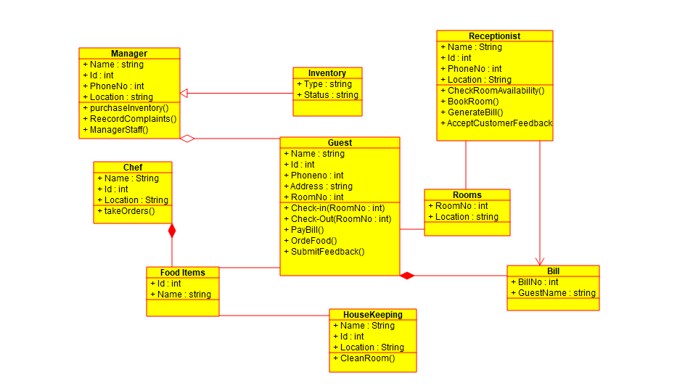

Documentation of Scenario: A Guest House.

This is a **Guesthouse system** where a **Guest** can go to a guesthouse and book a **Room** for a period of time to stay , the Guesthouse is run by Manager who controls the running of the Guesthouse, this Guest house also provide the guest with services for the guest to order food during the stay in the guesthouse. There is also the receptionist, who provide the guest with services to book an available room and provide the bill of all the services to the guest.

This is the class diagram of a guesthouse. It shows the relationship between various Classes in a guesthouse system.

Classes: there are various classes that make up the guesthouse system; these classes have attributes and operation, which are associated with them.

The class diagram shows each class in the system and the attributes and operation associated with this classes

The **Receptionist** class has relationship with the **Room** and **Bill** classes and which is also related to the **Guest** class, The **Guest** class is associated with more other classes : **FoodItems , Manager.**  The manager has relationship with the **Inventory** class